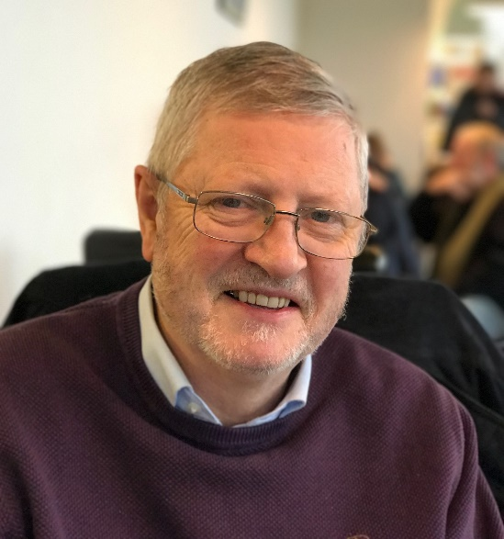
Tony Bardon Singer/ Songwriter Biography
I am a singer/songwriter living in Dublin. An early success was when my song “Going Away” was runner-up in the National Song Contest in 1971. Throughout my working life I continued to write and sing but it was only since I retired that I have been able to devote more time to pursuing my passion for music.
I am a Chartered Accountant by Profession and I worked as a senior manager in an international accounting firm and a multinational insurance company. Following my retirement, I trained and practiced as a Coach.
My current activities include writing, recording and performing my own songs, pursuing music-based projects both nationally and internationally and running a monthly songwriting workshops in the Irish Music Rights Organisation (IMRO) and Open Mics in Dublin as the Coordinator of “The Songwriting Collective”. (https://www.meetup.com/The-Songwriting-Collective/)
Over the past 10 years, I have run approximately 200 of these events. During the Covid Pandemic I brought these activities online and we are now getting ready to go back live again.
I have also done a considerable amount of pro-bono entertaining in local nursing homes.
I write on a wide range of topics from political parodies to spirituality.
For a number of years, I was a regular parody writer and singer on Joe Duffy’s Funny Friday Radio Show on RTE.
I have an interest in higher levels of consciousness, particularly the writings of American Philosopher Ken Wilber and his work on Integral Theory. I have been meditating for over 40 years. I am a leader in a local spirituality group, where we explore these issues in addition to non-duality/ Oneness
I have written and recorded an extensive body of Spiritual Songs including three Albums
The Greatest of These is Love
https://www.jamendo.com/album/50387/the-greatest-of-these-is-love

Songs from a Road Less Travelled
https://www.jamendo.com/album/54813/songs-from-a-road-less-travelled
Songs from the Ocean of Love
https://www.tonybardon.com/songs-from-the-ocean-of-love.html
In 2015, I recorded a CD and created a complimentary website based on the early lyrical poetry of WB Yeats on the 150th Anniversary of his birth called Songs from the Hazelwood. See www.hazelwoodsongs.com
In the last decade I participated in a number of EU funded projects with songwriting and music groups in Ireland and all across Europe where I performed on a regular basis
I acted as editor of “How to run effective Songwriting Workshops” on an EU Lifelong Learning Project, “Playing for Integration”
http://www.tonybardon.com/uploads/2/7/2/9/2729124/p4i_handbook.pdf
https://www.youtube.com/watch?v=BySiesHahek
I acted as coordinator on another EU Lifelong Learning Project “Preparing for Success in Music” and prepared the online documentation which included a Self-Coaching Toolbox for Musicians
http://www.musicianstoolbox.eu/
www.e-clef.net
For more information and to listen to my music check out www.tonybardon.com where free downloads of most of my songs are available.
I am looking forward to returning to live music soon with The Songwriting Collective and developing new performance opportunities where I can explore bringing my artistic career to a new level.

